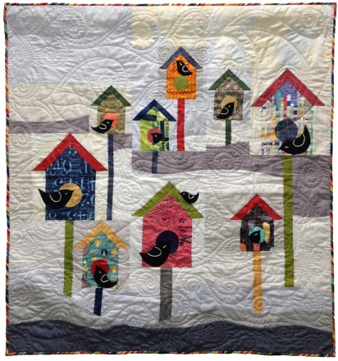
Winter Brrrd Houses
This quilt has the best of all techniques. The snow drifts are improvisational curved piecing. The birdhouses are pieced and fused. The cute little birds are stuffed and hand stitched. Learn all the techniques and you will be creating your own winter wonderland before the first frost arrives.
Pattern available.
6 hour class Intermediate level.
