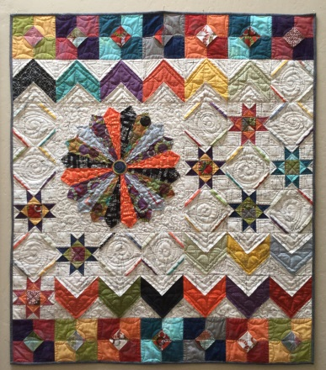
Shortcuts!
6 simple techniques that add a new twist on some old favorites blocks. Most blocks are 3 dimensional and so fun to make! You will use these techniques over and over again in future quilts. Pattern works well with most any fabric combination. Also designed to work well with pre-cut layer cakes.
Pattern available.
4-6 hour class Intermediate level.
