Amish Inspired Modern Workshop by Pati Fried
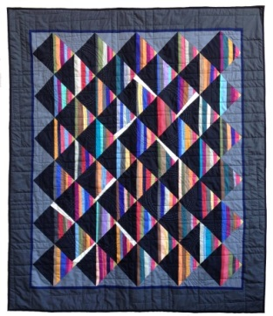
This a workshop to explore traditional Amish quilt designs & develop your own Amish-inspired modern quilt.
Begin with an Amish quilt design that you are drawn to. What are the elements that you like? What are the elements that you are ambivalent about or don’t like? These are your strengths and weaknesses of your inspiration quilt or muse. Keep these in mind, while reviewing the Modern Quilt Design Fundamentals. Could any of these be applied to your muse that would strengthen your own design? Do any of the fundamentals interest you to explore? Choose one or more of these fundamentals to begin. Think of it as a salad bar.
Modern Quilt Design Fundamentals:

Negative Space
Minimal Design
Lacking Borders
Bright & Graphic Color Palette
Improvisational Piecing
Gridwork
Assymetry
Modern Traditional Design
Exaggerated Scale
Pixelization
Texture
Less is More

- Use your grid paper to pencil out your quilt design layout. Estimate the size of your finished piece.
- Sketch out your block design. Break it down into the simplest elements. This will allow you to play with curves, improvisational piecing and color play as you go. It is a good idea to have a set grid, or a “trim out” size. This will help you to keep structure to your quilt when working with improvisational piecing. Too many biases make for a wonky structure.
- Start piecing! Strip piecing, quick half square triangle, curved piecing – it’s all a part of the design process. Make your block in a few different sizes and variations until you find the perfect block design.
- Use the graphs on the following pages to help you size and plan your original quilt design.

Please feel free to email me with any questions you may have. Pati@patifried.com www.patifried.com

