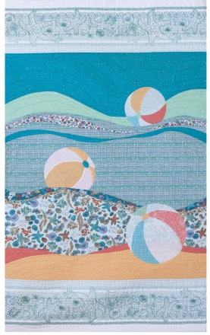

Making Waves
Pattern available.
6 hour class Intermediate level.
Create this graphic quilt and be all set for the beach this summer! Learn techniques for sewing big, improvisational curves that will have you making waves in no time. The beach balls are 3-dimensional applique’ and very fun to make. The quilt was designed for Windham Fabric’s Tidal Lace Collection, but works well with any water themed prints and also batiks.
