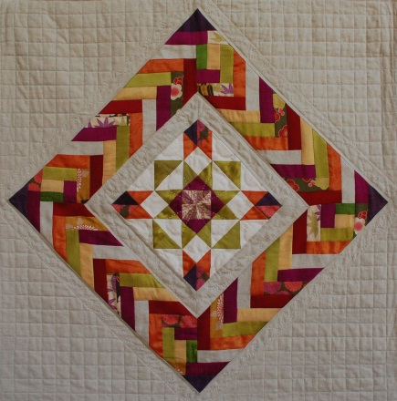
Continuous Braid Border
This beautiful braid border goes together quickly with a few tips and a special braid trimming ruler. The braid is continuous and doesn’t break the pattern, even when rounding the corners!. With a few tips and tricks, and a bit of math already figured out for you, you can leave class with a beautiful Continuous Braid Border. Bring a 12-14” square center block with you to class. This may be a panel, or a pieced or appliqued block. Supply list will give suggestions on how to choose the perfect palette of coordinating fabrics to bring this project to life! See class samples on Flicker.
Pattern and braid trimming ruler available.
4 hour class Intermediate level.
